**Training Data Set Creation**

The training data set used for this analysis is shown below (first 5 lines):  
<Fill In Screenshot>

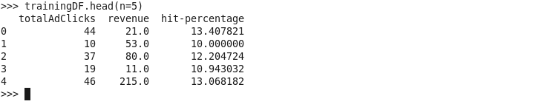

Dimensions of the training data set (rows x columns) : (543 x 3)

# of clusters created: 3